**Street Scout**

A GIS-based Street Asset Inventory Dashboard for Lahore

A Concept Note by

**Maira Khan**

(Urban Planner, Columbia University)

**Junaid Khan**

(Full-Stack Web Developer, LUMS)

**1. Executive Summary:**

Crowdsourcing has caught up as one of the most efficient data collection methods of the decade. City governments worldwide are saving millions by relying on data collected by the masses to understand and document their urban fabric and transport conditions. *Street Scout* is an application that will use crowdsourced geotagged street images, contributed by citizens, to develop a comprehensive inventory of Lahore’s street assets. These include street lamps, traffic lights, road signs, electric poles, street furniture, vegetation, barricades/diversions, bus stops, pavements, zebra-crossings, billboards, OHWTs, cars, bikes and pedestrians etc. The technology used to detect assets from the imagery is called Semantic Segmentation, and this analysis will be conducted using the [Mapillary](https://www.mapillary.com/)application. This data will be represented as a GIS-based interactive dashboard that shows the location of each asset on a street level map. This dashboard will allow government agencies to visualize, in a single glance, the disparity in street/road facilities throughout the city. An overlay of administrative boundaries will allow heads of Union Councils and Municipal Corporations to identify problems in their territory, and in turn plan new installations and manage existing assets more equitably. Clicking on each admin boundary will also provide with a statistical analysis of the state of these assets compared to the rest of the city. The application will work in real-time so that the dashboard is updated immediately with the assets detected from the latest imagery, to reflect the changes on ground. Government and other R&D departments (like the Urban Unit) that aim to conduct research can also request for this data as numeric files (Excel/Stata/Spss) or as GIS shapefiles. The application will be piloted in Lahore, but will later be made available for all the cities interested in partnering in this initiative.

**2. Introduction:**

**2.1. If you track it, you can fix it!**

Efficiently managing existing street/road assets and equitably planning for new ones can help minimize the total cost of owning and operating them. To do this, a detailed, accurate and regularly updated inventory of these assets must be maintained by city governments. This is a time and resource intensive process that requires hundreds of surveyors to go on ground and map the locations of these assets. Since cities are living organisms that change their form and shape constantly, establishing an inventory through this orthodox methodology and updating it in real-time is almost impossible. To solve this problem, *Street Scout* introduces intelligent and cost-effective crowdsourcing solution to develop a robust data management repository of public and privately owned street/road assets.

**2.2. How crowdsourcing works:**

Crowdsourcing is a combination of the words 'crowd' and 'outsourcing'. The idea is to take work and outsource it to a crowd of workers. It is an online, distributed problem-solving and production model that has grown in use in the past decade. Crowdsourcing has recently gained traction as a method for processing large batches of data to streamline government functions. For example, the government of Boston launched its first crowdsourced application, named *StreetBump***,** in 2012 to help locate open potholes in the city.

Our application, *Street Scout*, aims to motivate the public of Lahore to take pictures/videos/panorama views of their residential streets, daily commute routes, favorite walkways and recreational areas, roads and intersections, etc., and upload them to the app. All stationary and mobile assets visible in these crowdsourced geotagged photos will then be detected along with their locations using the Mapillary app, which uses Semantic Segmentation to make these detections.

**2.3. About Mapillary and Semantic Segmentation:**

Mapillary is a Swedish company that is using geotagged photos to create a street-view map of the world. One of the products of their application is to detect physical features like street lamps and traffic lights etc. present in the uploaded images. Our applicationwill partner with Mapillary to use this product for asset detection in our crowdsourced imagery. We are currently in talks with the company to develop this partnership.

The technology used to make these detections is called Semantic Segmentation, which involves using machine learning to understand an image at pixel level. Following are a few examples of how, and the detail and accuracy with which, this technology identifies physical features from within an image:

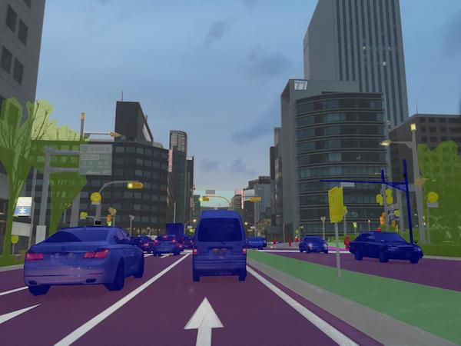 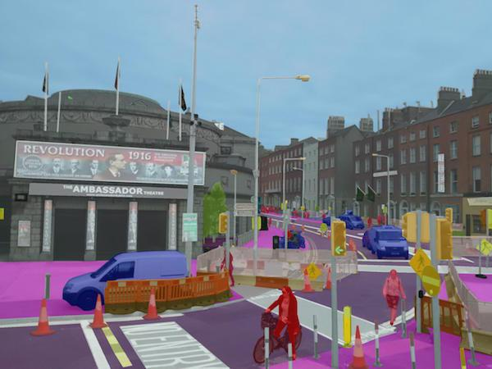

*Image source: https://www.mapillary.com/*

**2.4. Precedent city:**

In June 2017, the city of Amsterdam partnered with Mapillary to develop a similar asset inventory for its streets. The difference was that these images were collected by sending surveyors on ground. As a result, this was a one-time exercise and updating the inventory will require sending out teams to re-collect the data every time it is deemed obsolete. To avoid this problem, *Street Scout* will combine this methodology with crowdsourcing to make sure that the database is always up to date and the process is cost effective. Following image is a screenshot of the Amsterdam asset inventory:

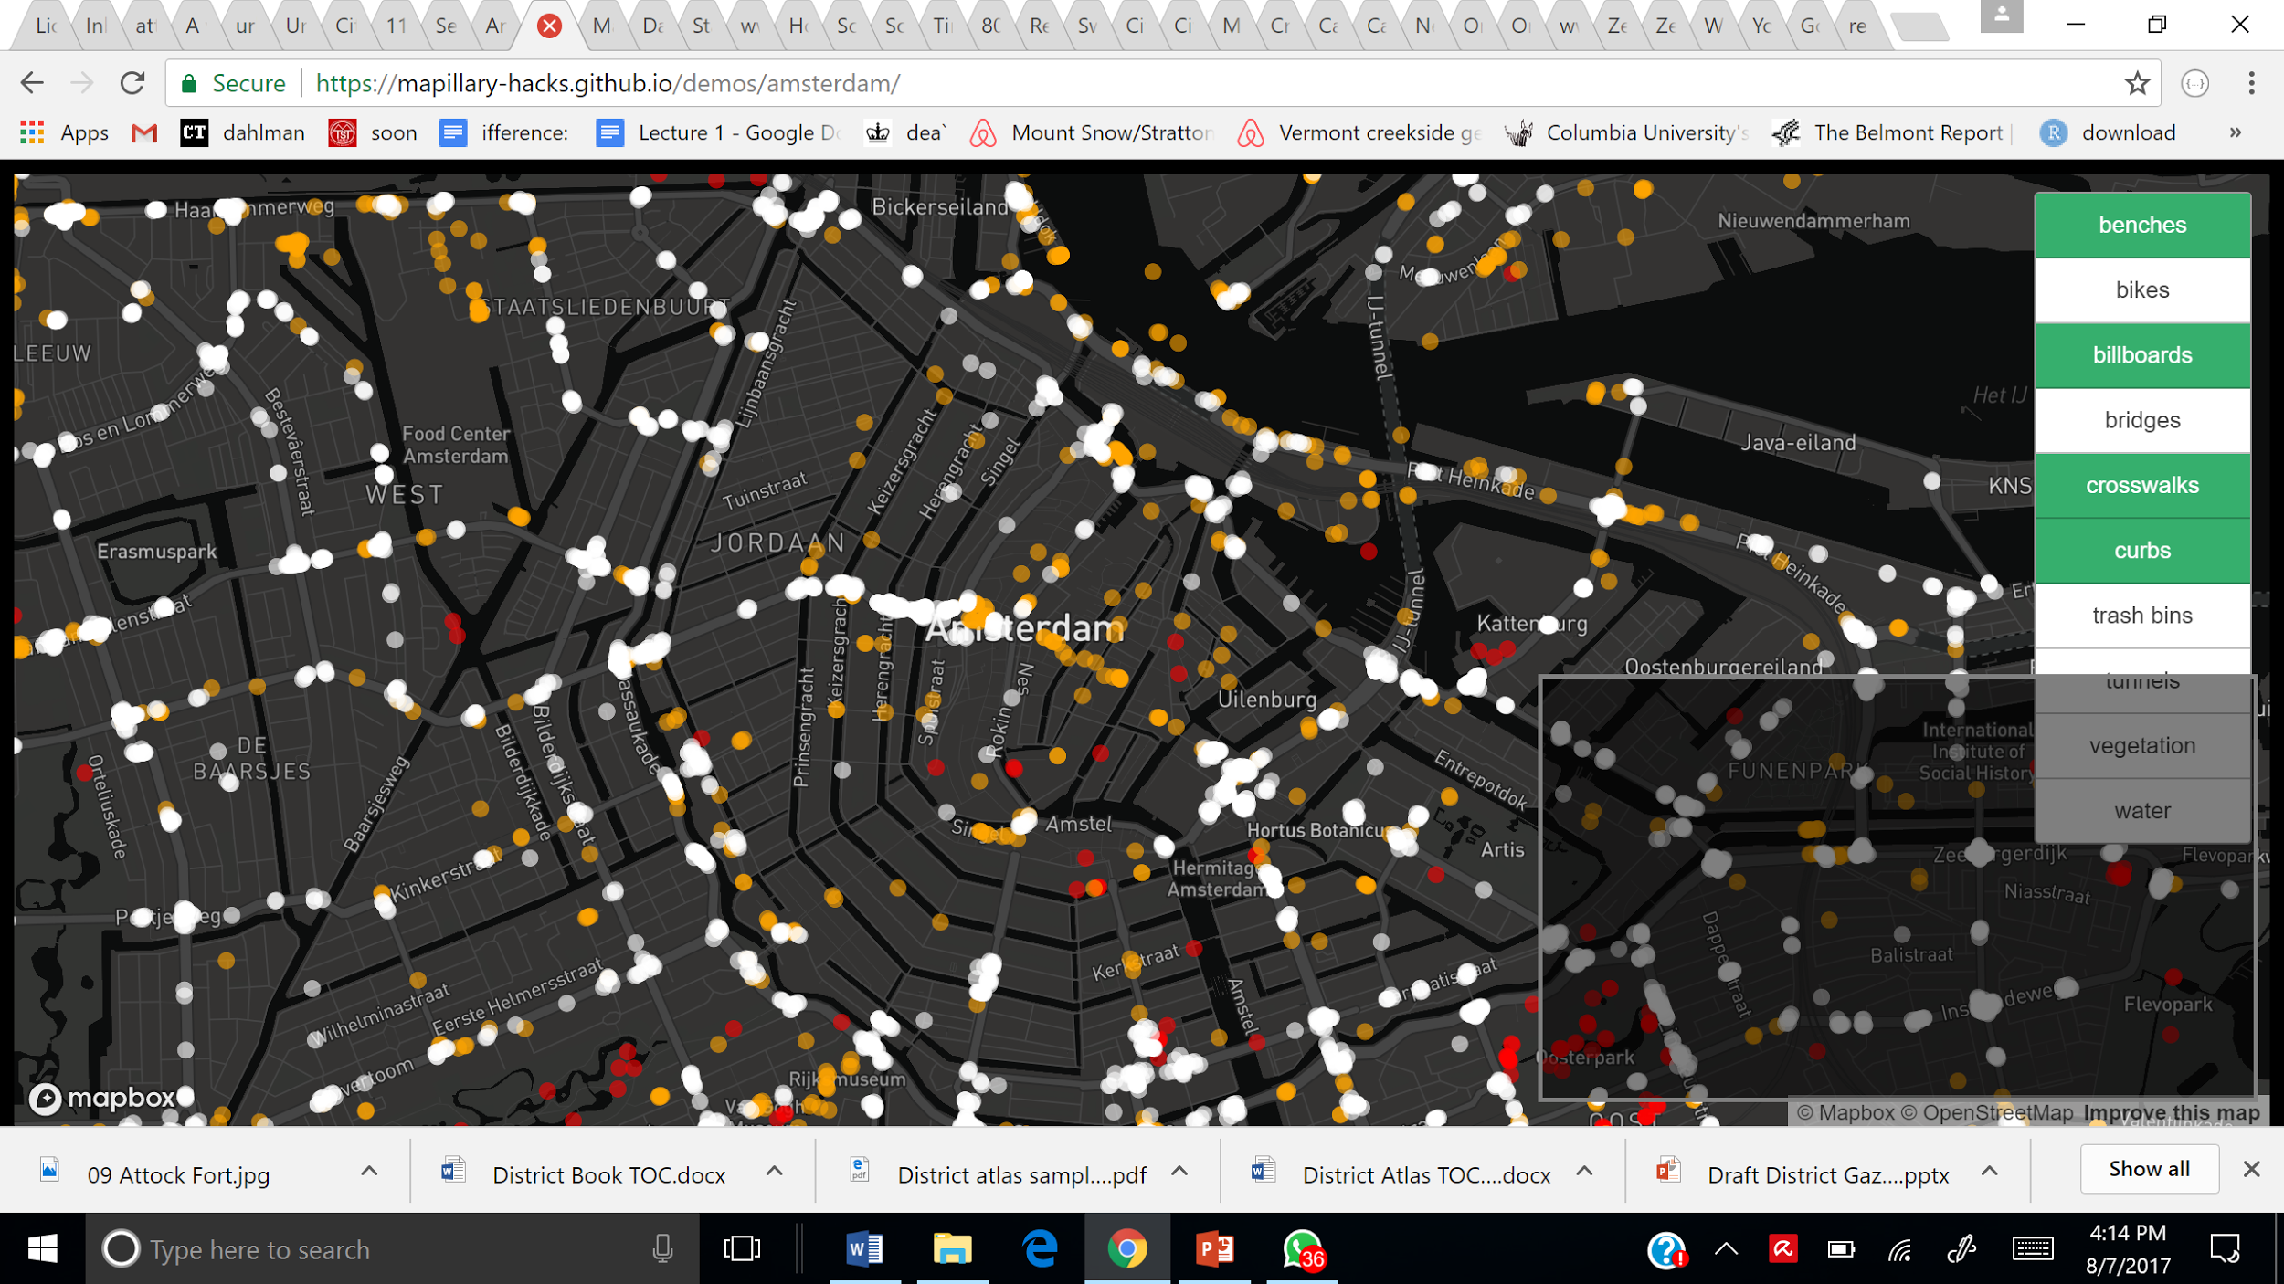

**3. Potential Clients:** For the Lahore pilot project, we hope to launch *Street Scout* in partnership with the Urban Unit and/or the Punjab Transportation Department, to develop the most comprehensive street asset inventory of the region as a part of their [IRIS](http://www.irispunjab.gov.pk/) and/or [PTIMS](http://www.tpu.punjab.gov.pk/punjab_transport_infrastructure_management_system) initiatives.

**4. Action Plan:**

**4.1. Step 1:** **Develop** ‘***Street Scout’* crowdsourcingapplication:**

Create a user friendly, contextualized, bilingual (Urdu / English) crowdsourcing mobile app that allows city residents to capture and upload pictures of their residential streets, daily commute routes, favorite walkways and recreational areas, roads and intersections, etc. These geo-tagged images will be uploaded to Mapillary in real-time where they will be combined to generate navigable street views.

To incentivize the contributors, the app will have a feature to direct every individual to a picture map/storyboard of his/her journey created by Mapillary and also be able to upload these stories to Facebook and Instagram.

**4.2. Step 2: Launch the *SHOUT OUT, STREET SCOUT!* Competition:**

To stimulate the crowdsourcing process, workshops will be held at university and college level where students will be introduced to the Street Scout app and will be encouraged to contribute towards completing the street-view coverage of their surrounding areas and places of interest. “SHOUT OUT, STREET SCOUT!” competition will then be held to accelerate data collection where participants with the greatest number of contributions over a period of 2 months will receive reward money. We will set up stalls in campuses to raise awareness and walk the students through the app.

**4.3. Step 3: Use Mapillary for asset detection:**

The captured images will be uploaded to Mapillary in real time. Geo-located street assets detected by Mapillary, through Semantic Segmentation, will then be queried for the uploaded images. We are currently in talks with Mapillary to get full access to their detected data APIs and also to figure out what all types of assets can be detected. This data will either be downloaded in raw form or will be received as shapefiles of assets.

**4.4. Step 4: Create GIS-based Street Asset Inventory Dashboard:**

Data collected will be used to create a GIS-based Street Asset Inventory Dashboard (that operates in real-time) for the Urban Unit and Transportation Department of Lahore.

The dashboard will identify location of each asset on an interactive GIS map. User can filter on the assets of their interest when conducting analysis. Concentration of a certain asset, for example street lights, in one part of the city and scarcity in another can help identify disparities in transport facilities in a single glance.

Union Council or census block boundaries will be overlaid on this map. Users will have the option to click on the administrative boundary of their interest and get a detailed statistical analysis of street assets for this area. They can also analyze it in comparison to other UCs or blocks. This tool will help governments maintain and expand transport facilities effectively and equitably.